Excuse me, How do I get to the tourist office?

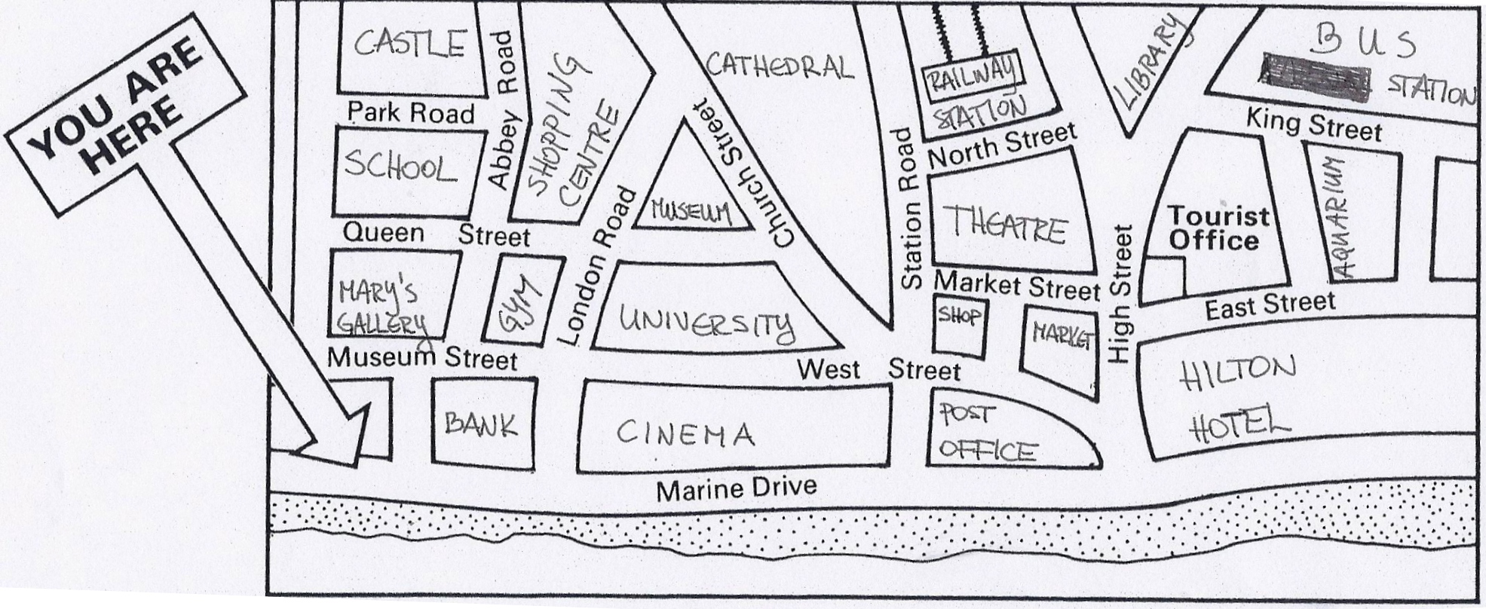

Excuse me, How do I get to the tourist office?

