



**HOLIDAYS**

* **Do you like beach holidays? Why/not? Why are they so popular?**
* **Do you usually go back to the same place every year for your holiday? Why/not?**
* **Do you prefer going on holiday with your family, with friends, or alone? Why?**
* **Do you enjoy being a tourist when you travel abroad?**
* **Why/not?**

1. Complete the gaps with the words from the box.

|  |
| --- |
| crowds work lift queue floor book good time  holiday resorts tourist traps make a complaint |

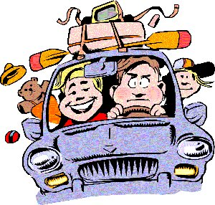

1. I had a_______________ on my last holiday. I really enjoyed myself.
2. I think________________are good places to go on holiday if you have young children. They
3. always have so many activities specifically for the tourists.
4. I______________________last time I went on holiday because I wasn't satisfied with the hotel.
5. The____________didn't____________in the hotel I stayed in on my last holiday so
6. I held to use the stairs. It wasn't funny - my room was on the eighth_________!
7. I hate____________________. That's why I avoid places where there are too many people.
8. I don't like_________________to get in to museums and art galleries because I hate waiting.
9. I try to avoid the_________________when I go on holiday because they are so expensive!
10. I always__________my holidays at the last minute because there are some good last-minute deals and cheap offers.