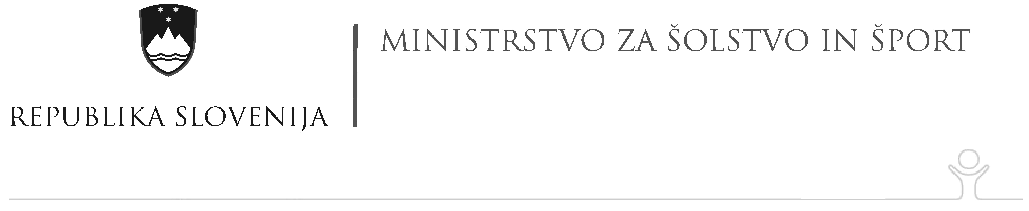

SOCIAL ENGLISH
- Vocabulary – DRINKS
Order the letters so that you get the names for the drinks in English.
- KILM ______milk_________
- RECOFE ___________________
- RETWA ___________________
- AET ___________________
- ANROEG CIJEU ___________________
- TIED KOCE ___________________
- RBEE ___________________
- EWNI ___________________

- Social English – Complete the dialogue with these words:
Can Let’s Nice OK Welcome
A: Hello. Are you Jack Horton?
B: Yes. Are you Moira?
A: Yes, I am. ________________ to meet you.
B: You too. ________________ to the UK. ___________________ I help you with your bags?
A: No, it’s _________, thanks.
B: My car is in the car park. Would you like coffee first?
A: No, thanks. I’m fine.
B: All right. ________________ go.

