



Vrh obrazca

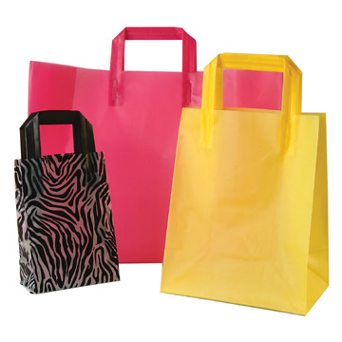

**Exercise: In the Ladies' Wear Department**

**Complete the dialogue. (typical dialogue with a female customer) ;o)**

* Shop assistant: Hello, can I ________________ you?
* Customer: I ________________ for a pair of jeans.
* Shop assistant: What ________________ do you take?
* Customer: Twenty-nine.
* Shop assistant: We have some very nice blue jeans here. They're ________________ this week.
* Customer: Well, I actually ________________ black jeans.
* Shop assistant: That's okay. We ________________ have them in black.
* Customer: Where can I ________________ them on?
* Shop assistant: The ________________ room is over there.  
    
  The customer tries the jeans on.
* Customer: They're ________________ big..
* Shop assistant: Would you like a ________________ size?
* Customer: Yes, ________________.  
    
  The customer tries the jeans on.
* Customer: These ________________ rather well. But I think I look ________________ in them. Don't you think?
* Shop assistant: Not at all. These jeans ________________ you very well.
* Customer: Well, I think I ________________ a blue pair.  
    
  The shop assistant brings a pair of blue jeans and the customer tries the jeans on.
* Customer: They are very ________________ and I don't like blue jeans, anyway. Do you mind ________________ me another pair in black?
* Shop assistant: No, not at all. …

Dno obrazca